1-

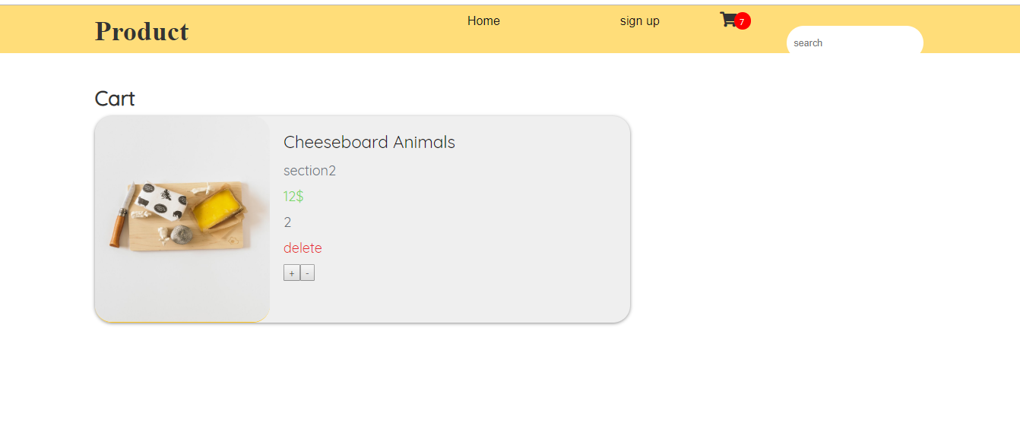

Product html

Click to insert pdt to cart package

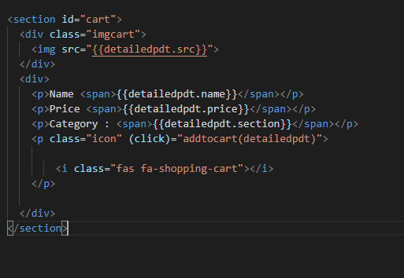

2-

Product tsfile to deliver pdt to cart

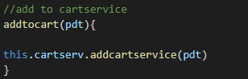

3-

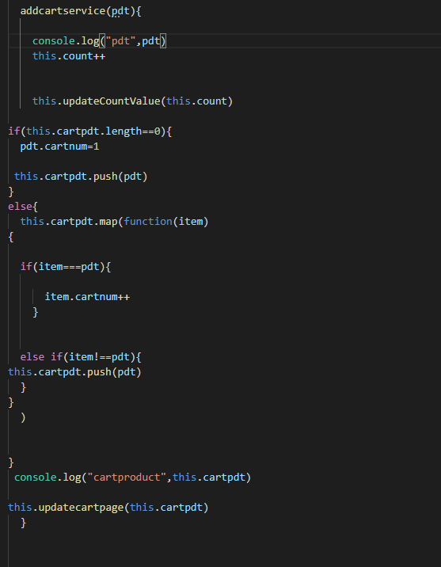

Product service to transfer pdt from detaile padge to cart page

5- cart tsfile

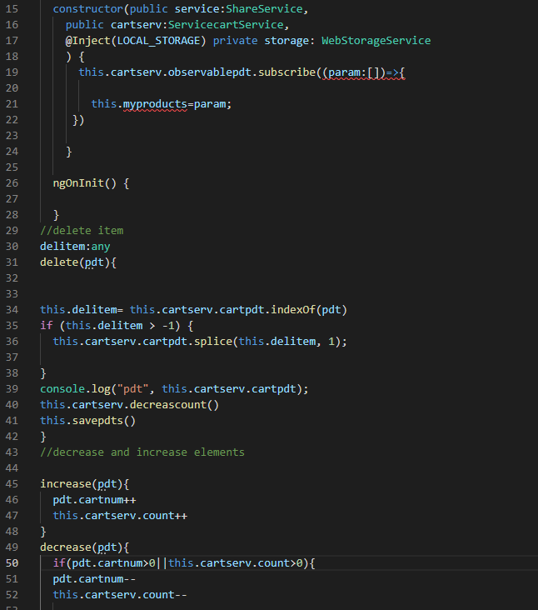

6-cart html

